Rating down for imprecision when effects are large: Assessing imprecision in the context of a large effect from a meta-analysis of trials with small sample sizes using binary and continuous outcomes
Here we provide a worked example of, in the context of an implausibly large effect with limited sample sizes, the approach to calculating the optimal information size (OIS) suggested in the main text, as well as
alternative approaches to addressing the OIS beyond the actual calculation of optimal information size presented in the main text.
OIS is akin to the concept of the required sample size in individual clinical trials. If the total number of patients included in a systematic review is less than the number of patients generated by a conventional sample size calculation for a single adequately powered trial, Core GRADE users consider rating down the certainty of evidence for imprecision.¹
Example 1: Consider a systematic review of randomized controlled trials that compared Lactated Ringer’s (LR) versus Normal Saline (NS) fluid resuscitation in patients with acute pancreatitis.² The meta-analysis of three randomized controlled trials concluded that compared to those who received NS, patients resuscitated with LR were less likely to require ICU admission (OR 0.33; 95 % CI 0.13-0.81). (Appendix 5 Figure 1)
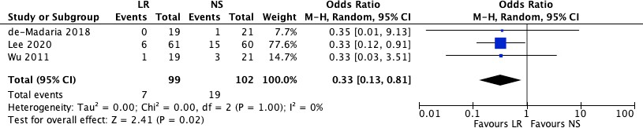
Figure 1. Meta-analysis of randomized controlled trials on Lactated Ringer’s (LR) versus Normal Saline (NS) fluid resuscitation for ICU admission in patients with acute pancreatitis
Let us assess the imprecision of the pooled effect with the null threshold. While the pooled effect of this meta-analysis appears sufficiently precise, the large effect (67% odds reduction) in the context of only 26 events overall (7/99 in LR versus 19/102 in NS) raises questions about the plausibility of the pooled effect and thus the possible desirability of rating down for imprecision. In other words, the large effect (in relative terms for binary outcomes) in the context of limited sample size and number of events triggers the need to address the OIS. We review here possible ways that Core GRADE users might go about addressing the issue.¹
3 4

Option 1: Using hypothesis testing approach to calculate OIS
OIS can be calculated using the following steps:
Step 1. Determine the expected effect size: Estimate the plausible magnitude of the effect that the
intervention is anticipated to have. For OIS we typically use relative risk reductions (RRR) of 20% or 25% as the expected effect size.
Step 2. Set the desired power and significance level: Typically, we use a power of 80% and a significance level of 5%.
Step 3. Use standard sample size formulas: Employ standard formulas for calculating sample size based on the type of outcome measure (e.g., binary, continuous). Many online calculators for sample size calculation
are available. One such online calculator is available at https://www.openepi.com/SampleSize/SSCohort.htm.
For the systematic review on RL versus NS, let us calculate the OIS for the outcome ICU admission using a
RRR of 25% as the expected effect size, with proportions with the outcome in intervention and control arm as 9% and 12% respectively. The OIS using these assumptions would be a total of 3406 (1703 in each arm), which was very far from being met in the meta-analysis (total number of patients across all trials 201). This would prompt authors to rate down for imprecision in the GRADE assessments.

Option 2: Using figures to determine OIS and minimum number of events
As an alternative to calculating the OIS, review and guideline authors can refer to a figure to determine the OIS.³ Appendix 4 Figure 2 shows the required sample size (assuming an alpha of 0.05 and a beta of 0.2) for relative risk reductions (RRR) of 20%, 25%, and 30% across various control event rates. In the pancreatitis example, if the estimated control event rate is 0.12 and an RRR of 25% is specified, the OIS is approximately 3500 patients. At the same control event rate, with a RRR of 20%, the OIS is approximately 6400, and with a RRR of 30%, the OIS is approximately 2500. Given that the total number of patients across all trials in the pancreatitis meta-analysis was only 201, which is way below the OIS indicated by these figures, authors would be urged to rate down for imprecision in the GRADE assessments.
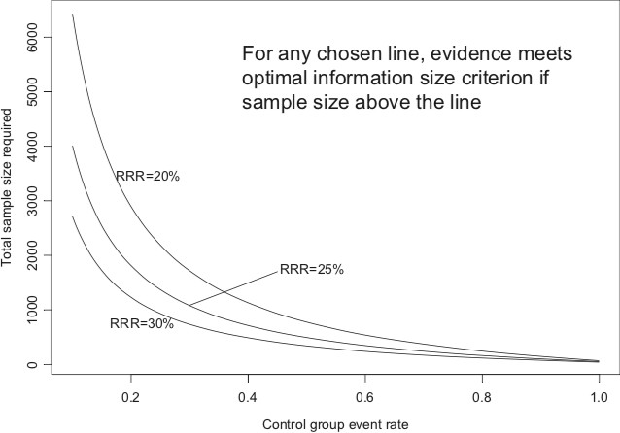
Figure 2. Optimal information size given a of 0.05 and b of 0.2 for varying control event rates and relative risks.³
However, power is more closely related to the number of events than to sample size. Appendix 4 Figure 3 illustrates the same relationships using the total number of events across all studies in both the treatment and control groups instead of the total number of patients. Keeping the same assumptions as in the prior paragraph (control event rate 0.12 and RRR 25%), one requires approximately 360 events to meet OIS
criteria. Similarly, keeping the control events rate at 0.12, a RRR of 20% and 30% would require
approximately 630 and 250 events respectively to meet OIS criteria. The total number of events across all trials in the pancreatitis example is only 26, far below the OIS. This would prompt authors to rate down for imprecision.
Figure 3. Optimal information size presented as number of events given a of 0.05 and b of 0.20 for varying control event rates and RRR of 20%, 25% and 30%. Abbreviation: RRR, relative risk reduction.³
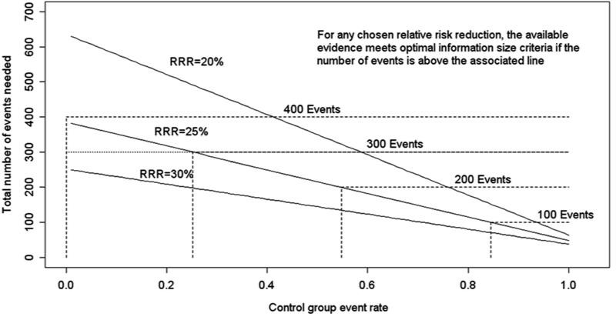

Option 3: Assessing if the ratio of the upper to the lower boundary of the CI is more than 2.5 for odds ratio (OR) or 3 for Risk Ratio (RR)
The ratio of upper and lower boundary of the CI may indicate if the sample size in the meta-analysis is less than the OIS if it is greater than 2.5 for OR and 3 for RR.⁴ This may in fact preclude the need to carry out a calculation of OIS for the meta-analysis. For the example above, a relative effect of 67% reduction in odds of patients requiring ICU admission represents a large, probably implausible effect with a small sample size of 201 (number of events=26), and systematic reviewers and guideline developers would therefore want to determine whether the OIS is met.
When, as in this situation, the sample size or number of events is far lower than the OIS, Core GRADE users should consider rating down twice for imprecisions. The criterion we suggest for this decision is to look at the ratio of the upper CI boundary to the lower CI boundary: if that ratio is larger than 2.5, we suggest to rate down twice. ¹ In this case the number of events is almost an order of magnitude less than the OIS, and the of the upper boundary of the CI (0.81) to the lower CI boundary (0.13) for the OR is 6.2 which is larger than 2.5. This suggests the appropriateness of rating down two levels for imprecision.
Example 2: Consider a systematic review of randomized controlled trials for stem cell therapy for chronic liver disease.⁵ Appendix 4 Figure 4 depicts the results of the meta-analysis for the outcome MELD score MELD
(Model for End-Stage Liver Disease) at 8 weeks, arising from four trials with a total of 248 participants studying stem cell therapies versus standard of care. The score is a numerical scale used to assess the
severity of chronic liver disease and prioritize patients for liver transplantation, with a higher score indicating a more severe liver disease and a greater urgency for liver transplantation. For dichotomous outcomes, it is recommended to rate down two levels if the upper-to-lower CI ratio exceeds 2.5 for odds ratios or 3 for risk ratios. For continuous outcomes, rate down two levels if the total sample size is less than 30–50% of the
optimal information size. ¹
Let us assess the imprecision of the pooled effect with the threshold being an MID of 4. The confidence interval (-2.45 to -1.05) seems sufficiently precise with respect to this threshold. If we would rate the
certainty that stem cell therapy had an important reduction in MELD score (i.e., the target of certainty rating), we would not rate down for imprecision.
One can make a calculation of OIS for this outcome by specifying the MID and the standard deviation from one of the existing studies. Alternatively, a rule of thumb would be to not rate down for imprecision if there are a minimum of 400 patients per group (i.e., a total of 800 patients). Since the given meta-analysis has a total of only 248 patients across all trials, this would prompt us to rate down for imprecision using these
criteria.
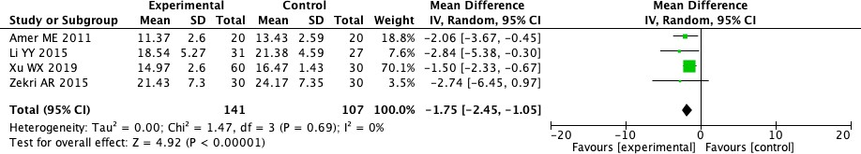
Figure 4. Meta-analysis of randomized controlled trials on stem cell therapy for reduction in MELD score in chronic liver disease

References
- Zeng L, Brignardello-Petersen R, Hultcrantz M, et al. GRADE Guidance 34: update on rating imprecision using a minimally contextualized approach. J Clin Epidemiol 2022;150:216-24. doi:
10.1016/j.jclinepi.2022.07.014 [published Online First: 20220804]
- Zhou S, Buitrago C, Foong A, et al. Comprehensive meta-analysis of randomized controlled trials of
Lactated Ringer's versus Normal Saline for acute pancreatitis. Pancreatology 2021;21(8):1405-10. doi: 10.1016/j.pan.2021.07.003 [published Online First: 20210726]
- Guyatt GH, Oxman AD, Kunz R, et al. GRADE guidelines 6. Rating the quality of evidence--imprecision. J Clin Epidemiol 2011;64(12):1283-93. doi: 10.1016/j.jclinepi.2011.01.012 [published Online First: 20110811]
- Brignardello-Petersen R, Guyatt GH, Mustafa RA, et al. GRADE guidelines 33: Addressing imprecision in a network meta-analysis. J Clin Epidemiol 2021;139:49-56. doi: 10.1016/j.jclinepi.2021.07.011
[published Online First: 20210719]
- Zhou GP, Jiang YZ, Sun LY, et al. Therapeutic effect and safety of stem cell therapy for chronic liver disease: a systematic review and meta-analysis of randomized controlled trials. Stem Cell Res Ther
2020;11(1):419. doi: 10.1186/s13287-020-01935-w [published Online First: 20200925]

